**509 ARMY BASE WORKSHOP**

INDUSTRIAL TRAINING PROJECT



**PROJECT NAME**

**PASS MANAGEMENT SYSTEM**

**PROJECT NO.: 1**

**SUBMITTED TO: SUBMITTED BY:** COMMANDANT & MD SHRUTI SINGH

509 ARMY BASE WORKSHOP, BHOR KULSHRESHTHA

AGRA VISHWANATH PRATAP SINGH

YAMINI CHAHAR

**Project done at 509 Army Base Workshop, Agra**

**509 ARMY BASE WORKSHOP, AGRA**

**CERTIFICATE**

We hereby submit the project entitled **“PASS MANAGEMENT SYSTEM”** for the 509 Army Base workshop, under the supervision of Col R D MATHUR, 509 Army Base Workshop, Agra, Uttar Pradesh, India.

Syndicate members:

1.Shruti Singh (Anand Engineering college, Agra, Uttar Pradesh)

2.Yamini Chahar (Faculty of Engineering and Technology, Agra, Uttar Pradesh)

3.Bhor Kulshreshtha (Faculty of Engineering and Technology, Agra, Uttar Pradesh)

4.Vishwanath Pratap Singh (Faculty of Engineering and Technology, Agra, Uttar Pradesh)

This project report is hereby approved for submissions.

Date: SIGNATURE

**ACKNOWLEDGEMENT**

First of all, we are indebted to the GOD ALMIGHTY for giving us an opportunity to excel in our efforts to complete this project on time.

We are extremely grateful to Col R D MATHUR, 509 Army Base Workshop for providing all the required resources for the successful completion of this project.

Our heartfelt gratitude for his valuable suggestions and guidance for the preparation of the project report.

We are extremely grateful to all our syndicate members for the help and coordination extended in bringing out this project successfully in time.

We will be falling in duty if we do not acknowledge with grateful thanks to the authors of the references and other literatures referred to in this project.

Last but not the least, we are very much thankful to our parents who guided us in every step which we took.

**INDEX**

**Abstract**

**1.Introduction**

1.1 Objective

1.2 Functionalities

1.3 Scope

1.4 Modules

1.5 Features of the project

1.6 Identification of the need

1.7Feasibility Study

**2.SOFTWARE REQUIREMENTS SPECIFICATION**

2.1 Hardware requirements

2.2 software requirements

**3.Design and planning**

3.1 Software Development Life Cycle

## 3.2 User interface design

## 3.3 preliminary product description

**4.Implementation details**

4.1 Front end

4.2 Back end

## 5. Testing and Implementation

## 5.1 Unit testing

## 5.2 Integration testing

## 5.3. software verification and validation

## 5.4 black-box testing

## 5.5 White-Box Testing

## 5.6 System testing

## 6. Advantages of Pass Management System

## 7. Screenshots

**8. Limitation of Project on Pass Management System**

## 9.Future Scope of the Project:

## 10.Conclusion

### **11.References and Bibliography:**

**ABSTRACT**

The main objective of the Pass Management System is to manage the NTR and DTR details of the employees of 509 ARMY BASE WORKSHOP. It allows the admin to manage the NTR and DTR and enables the employees to apply for NTR and DTR. The purpose of Pass Management System is to automate the existing manual system with the help of computerized equipments and full-fledged computer software, fulfilling their requirements, so that their valuable data/information can be stored for a longer period with easy accessing and manipulation of the same. The required software and hardware are easily available and easy to work with.

Pass Management System, as described above, can lead to error free, secure, reliable and fast management system. It can assist the user to concentrate on their other activities rather to concentrate on the record keeping. It will also help the administration to access the data in more efficient way. It will help the organization in better utilization of resources. The organization can maintain computerized records without redundant entries. That means that one need not be distracted by information that is not relevant, while being able to reach the information.

The aim is to automate its existing manual system by the help of computerized equipments and full-fledged computer software, fulfilling their requirements, so that their valuable data/information can be stored for a longer period with easy accessing and manipulation of the same. Basically, the project describes how to manage good performance and better services for the administration and user.

1. **INTRODUCTION**

## 1.1Objective of Project on Pass Management System:

The main objective of our project Pass Management System is to manage the details of Employee, NTR and DTR taken by them and previous NTR/DTR details. It also provides the facility to generate the Pdf of NTR/DTR pass. It manages all the information related to NTR/DTR and employee. The project is built at administrative end and user end with different functionalities. The Super Admin is guaranteed the access of all data. Admin handles the data of the employees of its department. User can apply for NTR/DTR and generate pdf. The purpose of the project is to build an application program to reduce the manual work.

### **1.2 Functionalities provided by Pass Management System are as follows:**

* Provides the searching facilities to Admin and Super Admin to search for NTR/DTR and employees.
* Pass Management System also manage the pass type details.
* It tracks all the information of pass, pass type etc.
* Manage the information of employees.
* Shows the information and description of the Employee and NTR/DTR taken by him.
* Increase the efficiency of managing the NTR/DTR details.
* It deals with monitoring the information about NTR/DTR taken by an employee.
* Manage the information of Employee.
* Editing, adding and updating of records can be done by Super Admin.
* Admin has the power to manage the NTR/DTR of its department.
* Employee can apply for NTR/DTR and can generate the Pdf.

## 1.3 Scope of the project Pass Management System

It may help collecting perfect management in details. In a very short time, the collection will be obvious, simple and sensible. It will help the Admin, employees and Super Admin in the whole process of requesting and granting NTR/DTR. It helps in all current work related to Pass Management System. It will be also reduced the cost of collecting the management & collection procedure will go on smoothly. It will provide real-time information and updates. It also saves the time of administration.

We have tried to computerize various processes of Pass Management

* + In computer system the person can apply for NTR/DTR & number of copies of the slip can be easily generated at a time.
  + In computer system, it is not necessary to create the manifest but we can directly print it, which saves our time.
  + To assist the staff in capturing the effort spent on their respective working areas.
  + To utilize resources in an efficient manner by increasing their productivity through automation.
  + The system generates types of information that can be used for various purposes.
  + It satisfies the user requirement.
  + Be easy to understand by the user and operator.
  + Be easy to operate.
  + Have a good user interface.
  + Be expandable.
  + Delivered on schedule within the budget.

## 1.4 Modules of Employee Leave Management System:

* **Login:** Every user can login using their respective empid and password.
* **Add:** Super Admin can add new admins and employees.
* **Delete:** Super Admin and admin can delete the record of NTR and DTR of particular user.

## 1.5 Features of the project Pass Management System:

* Creating & Changing Issues at ease
* Query Issue List to any depth
* Reporting & Charting in more comprehensive way
* User Accounts to control the access and maintain security
* Simple Status & Resolutions
* Multi-level Priorities & Severities.
* Targets & Milestones for guiding the programmers
* Attachments & Additional Comments for more information
* Robust database back-end
* Various level of reports available with a lot of filter criteria’s
* It contains better storage capacity.
* Accuracy in work.
* Easy & fast retrieval of information.
* Well-designed reports.
* Decrease the load of the person involve in existing manual system.
* Access of any information individually.
* Work becomes very speedy.
* Easy to update information

## 

## 1.6 Identification of need:

The old manual system was suffering from a series of drawbacks. Since whole of the system was to be maintained with hands the process of keeping, maintaining and retrieving the information was very tedious and lengthy. The records were never used to be in a systematic order. There used to be lots of difficulties in associating any particular transaction with a particular context. If any information was to be found it was required to go through the different registers, documents there would never exist anything like report generation. There would always be unnecessary consumption of time while entering records and retrieving records. One more problem was that it was very difficult to find errors while entering the records. Once the records were entered it was very difficult to update these records.

The reason behind it is that there is lot of information to be maintained and have to be kept in mind in organization. For this reason, we have provided features Present system is partially automated (computerized), actually existing system is quite laborious as one has to enter same information different places. It reduces the human efforts of checking the papers for Pass taken by the employees manually and maintaining it in folders and files.

With the implementation of computerized system, the task of keeping records in an organized manner will be solved. The greatest of all is the retrieval of information, which will be at the click of the mouse. So, the proposed system helps in saving the time in different operations and making information flow easy giving valuable reports.

**1.7 FEASIBILITY STUDY**

A feasibility study is a high-level capsule version of the entire System analysis and Design Process. The study begins by classifying the problem definition. Feasibility is to determine if it’s worth doing. Once an acceptance problem definition has been generated, the analyst develops a logical model of the system. A search for alternatives is analyzed carefully.

There are 3 parts in feasibility study:

1) Operational Feasibility

2) Technical Feasibility

3) Economical Feasibility

**OPERATIONAL FEASIBILITY**

Operational feasibility is the measure of how well a proposed system solves the problems, and takes advantage of the opportunities identified during scope definition and how it satisfies the requirements identified in the requirements analysis phase of system development. The operational feasibility assessment focuses on the degree to which the proposed development projects fits in with the existing environment. To ensure success, desired operational outcomes must be imparted during design and development. These include such design-dependent parameters as reliability, maintainability, supportability, usability, producibility, disposability, sustainability, affordability and others. These parameters are required to be considered at the early stages of design if desired operational behaviours are to be realised. A system design and development require appropriate and timely application of engineering and management efforts to meet the previously mentioned parameters. A system may serve its intended purpose most effectively when its technical and operating characteristics are engineered into the design. Therefore, operational feasibility is a critical aspect of systems engineering that needs to be an integral part of the early design phases.

**TECHNICAL FEASIBILITY**

This involves questions such as whether the technology needed for the system exists, how difficult it will be to build, and whether the firm has enough experience using that technology. The assessment is based on outline design of system requirements in terms of input, processes, output, fields, programs and procedures. This can be qualified in terms of volume of data, trends, frequency of updating in order to give an introduction to the technical system. The application is the fact that it has been developed on windows XP platform and a high configuration of 1GB RAM on Intel Pentium Dual core processor. This is technically feasible. The technical feasibility assessment is focused on gaining an understanding of the present technical resources of the organization and their applicability to the expected needs of the proposed system. It is an evaluation of the hardware and software and how it meets the need of the proposed system.

**ECONOMICAL FEASIBILITY**

Establishing the cost-effectiveness of the proposed system i.e., if the benefits do not outweigh the costs, then it is not worth going ahead. In the fast-paced world today there is a great need of online social networking facilities. Thus, the benefits of this project in the current scenario make it economically feasible. The purpose of the economic feasibility assessment is to determine the positive economic benefits to the organization that the proposed system will provide. It includes quantification and identification of all the benefits expected. This assessment typically involves a cost/benefits analysis.

**2.SOFTWARE REQUIREMENTS SPECIFICATION**

**2.1 Hardware Requirements**

|  |  |
| --- | --- |
| **NUMBER** | **DESCRIPTION** |
| 1 | PC with 250 GB or more hard disk. |
| 2 | PC with 2 GB RAM. |
| 3 | PC with Pentium 1 and above. |

**2.2 Software Requirements**

|  |  |  |
| --- | --- | --- |
| **NUMBER** | **DESCRIPTION** | **Type** |
| 1 | Operating System | Windows XP/Windows |
| 2 | Language | PHP |
| 3 | Database | MySQL |
| 4 | IDE | Visual Studio Code |
| 5 | Browser | Google Chrome |

**3.DESIGN & PLANNING**

**3.1 Software Development Life Cycle**

In this phase, a logical system is built which fulfils the given requirements. Design phase of software development deals with transforming the clients’s requirements into a logically working system.

**WATERFALL MODEL**

The waterfall model was selected as the SDLC model due to the following reasons:

● Requirements were very well documented, clear and fixed.

● Technology was adequately understood.

● Simple and easy to understand and use.

● There were no ambiguous requirements.

● Easy to manage due to the rigidity of the model. Each phase has specific deliverables and a review process.

● Clearly defined stages.

● Well understood milestones. Easy to arrange tasks.

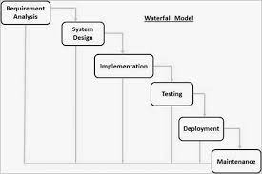

## 3.2 User Interface Design

User Interface Design is concerned with the dialogue between a user and the computer. It is concerned with everything from starting the system or logging into the system to the eventually presentation of desired inputs and outputs. The overall flow of screens and messages is called a dialogue.

### **The following steps are various guidelines for User Interface Design:**

1. The system user should always be aware of what to do next.
2. The screen should be formatted so that various types of information, instructions and messages always appear in the same general display area.
3. Message, instructions or information should be displayed long enough to allow the system user to read them.
4. Use display attributes sparingly.
5. Default values for fields and answers to be entered by the user should be specified.
6. A user should not be allowed to proceed without correcting an error.
7. The system user should never get an operating system message or fatal error.

## 3.3 Preliminary Product Description:

The first step in the system development life cycle is the preliminary investigation to determine the feasibility of the system. The purpose of the preliminary investigation is to evaluate project requests. It is not a design study nor does it include the collection of details to describe the business system in all respect. Rather, it is the collecting of information that helps committee members to evaluate the merits of the project request and make an informed judgment about the feasibility of the proposed project.

### **3.3.1 Analysts working on the preliminary investigation should accomplish the following objectives:**

* Clarify and understand the project request
* Determine the size of the project.
* Assess costs and benefits of alternative approaches.
* Determine the technical and operational feasibility of alternative approaches.
* Report the findings to management, with recommendations outlining the acceptance or rejection of the proposal.

### **Benefit to Organization**

The organization will obviously be able to gain benefits such as reduction in paperwork, better utilization of human resources and more presentable image increasing goodwill.

### **The Initial Cost**

The initial cost of setting up the system will include the cost of hardware software (OS, add-on software, utilities) and labour(setup and maintenance). The same has to bear by the organization.

### **Running Cost**

Besides, the initial cost the long-term cost will include the running cost for the system including the AMC, stationary charges, cost for human resources, cost for update/renewal of various related software.

### **Need for Training**

The users along with the administrator need to be trained at the time of implementation of the system for smooth running of the system. The client will provide the training site.

We talked to the management people who were managing the financial issues of the center, the staff who were keeping the records in lots of registers and the reporting manager regarding their existing system, their requirements and their expectations from the new proposed system. Then, we did the system study of the entire system based on their requirements and the additional features they wanted to incorporate in this system.

Reliable, accurate and secure data was also considered to be a complex task without this proposed system

The new system proposed and then developed by our team will ease the task of the organization in consideration. It will be helpful in generating the required reports by the staff, which will help them to track their progress and services.

Thus, it will ease the task of Management to a great extent as all the major activities to be performed, are computerized through this system

**4.IMPLEMENTATION DETAILS**

In this Section we will do Analysis of Technologies to use for implementing the project.

**4.1 FRONT END**

**1.HTML**



Hypertext Markup Language (HTML) is the standard markup language for documents designed to be displayed in a web browser. It can be assisted by technologies such as Cascading Style Sheets (CSS) and scripting languages such as JavaScript. Web browsers receive HTML documents from a web server or from local storage and render the documents into multimedia web pages. HTML describes the structure of a web page semantically and originally included cues for the appearance of the document.

HTML elements are the building blocks of HTML pages. With HTML constructs, images and other objects such as interactive forms may be embedded into the rendered page. HTML provides a means to create structured documents by denoting structural semantics for text such as headings, paragraphs, lists, links, quotes and other items. HTML elements are delineated by tags, written using angle brackets. Tags such as <img/> and <input/> directly introduce content into the page. Other tags such as <p> surround and provide information about document text and may include other tags as sub-elements. Browsers do not display the HTML tags, but use them to interpret the content of the page.

HTML can embed programs written in a scripting language such as JavaScript, which affects the behaviour and content of web pages. Inclusion of CSS defines the look and layout of content. The World Wide Web Consortium (W3C), former maintainer of the HTML and current maintainer of the CSS standards, has encouraged the use of CSS over explicit presentational HTML since 1997.

**2. Css**

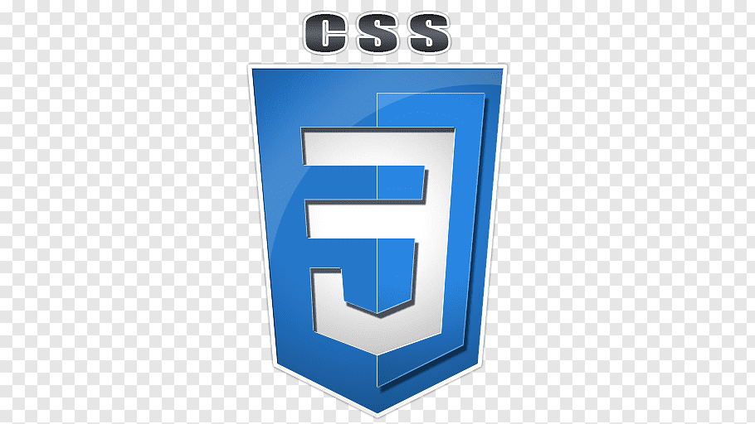

Cascading Style Sheets (CSS) is a style sheet language used for describing the presentation of a document written in a markup language like HTML.CSS is a cornerstone technology of the World Wide Web, alongside HTML and JavaScript.CSS is designed to enable the separation of presentation and content, including layout, colours, and fonts. This separation can improve content accessibility, provide more flexibility and control in the specification of presentation characteristics, enable multiple web pages to share formatting by specifying the relevant CSS in a separate. Css file, and reduce complexity and repetition in the structural content.

CSS information can be provided from various sources. These sources can be the web browser, the user and the author. The information from the author can be further classified into inline, media type, importance, selector specificity, rule order, inheritance and property definition. CSS style information can be in a separate document or it can be embedded into an HTML document. Multiple style sheets can be imported. Different styles can be applied depending on the output device being used; for example, the screen version can be quite different from the printed version, so that authors can tailor the presentation appropriately for each medium. The style sheet with the highest priority controls the content display. Declarations not set in the highest priority source are passed on to a source of lower priority, such as the user agent style. The process is called cascading.

One of the goals of CSS is to allow users greater control over presentation. Someone who finds red italic headings difficult to read may apply a different style sheet. Depending on the browser and the web site, a user may choose from various style sheets provided by the designers, or may remove all added styles and view the site using the browser's default styling, or may override just the red italic heading style without altering other attributes

**4.2 BACK END**

1. **PHP** 

PHP is a server-side scripting language that is used to develop Static websites or Dynamic websites or Web applications. PHP stands for Hypertext Pre-processor, that earlier stood for Personal Home Pages. PHP scripts can only be interpreted on a server that has PHP installed. The client computers accessing the PHP scripts require a web browser only. A PHP file contains PHP tags and ends with the extension ".php". The term PHP is an acronym for PHP: Hypertext Pre-processor. PHP is a server-side scripting language designed specifically for web development. PHP can be easily embedded in HTML files and HTML codes can also be written in a PHP file. The thing that differentiates PHP with client-side language like HTML is, PHP codes are executed on the server whereas HTML codes are directly rendered on the browser. Hypertext Pre-processor (or simply PHP) is a general-purpose programming language originally designed for web development. It was originally created by Rasmus Lerdorf in 1994.PHP code may be executed with a command line interface (CLI), embedded into HTML code, or used in combination with various web template systems, web content management systems, and web frameworks. PHP code is usually processed by a PHP interpreter implemented as a module in a web server or as a Common Gateway Interface (CGI) executable. The web server outputs the results of the interpreted and executed PHP code, which may be any type of data, such as generated HTML code or binary image data. PHP can be used for many programming tasks outside of the web context, such as standalone graphical applications and robotic drone control.

1. **MySQL**

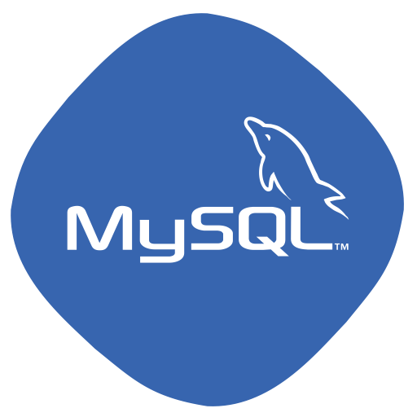

MySQL is an open-source relational database management system (RDBMS) based on Structured Query Language (SQL). It is one part of the very popular XAMPP platform consisting of Apache, My SQL, Perl, and PHP. Currently My SQL is owned by Oracle. My SQL database is available on most important OS platforms. It runs on BSD Unix, Linux, Windows, or Mac OS. Wikipedia and YouTube use My SQL. These sites manage millions of queries each day. My SQL comes in two versions: My SQL server system and My SQL embedded system.

RDBMS TERMINOLOGY

Before we proceed to explain MySQL database system, let's revise few definitions related to database.

● Database: A database is a collection of tables, with related data.

● Table: A table is a matrix with data. A table in a database looks like a simple spreadsheet.

● Column: One column (data element) contains data of one and the same kind, for example the column postcode.

● Row: A row (= tuple, entry or record) is a group of related data, for example the data of one subscription.

● Redundancy: Storing data twice, redundantly to make the system faster.

● Primary Key: A primary key is unique. A key value cannot occur twice in one table. With a key, you can find at most one row.

● Foreign Key: A foreign key is the linking pin between two tables.

● Compound Key: A compound key (composite key) is a key that consists of multiple columns, because one column is not sufficiently unique.

● Index: An index in a database resembles an index at the back of a book.

● Referential Integrity: Referential Integrity makes sure that a foreign key value always points to an existing ro

## 

## 5. TESTING AND IMPLEMENTATION

The term implementation has different meanings ranging from the conversation of a basic application to a complete replacement of a computer system. The procedures however, are virtually the same. Implementation includes all those activities that take place to convert from old system to new. The new system may be totally new replacing an existing manual or automated system or it may be major modification to an existing system. The method of implementation and time scale to be adopted is found out initially. Proper implementation is essential to provide a reliable system to meet organization requirement.

## 5.1 UNIT TESTING

### **Introduction**

In computer programming, unit testing is a software testing method by which individual units of source code, sets of one or more computer program modules together with associated control data, usage procedures, and operating procedures, are tested to determine whether they are fit for use. Intuitively, one can view a unit as the smallest testable part of an application. In procedural programming, a unit could be an entire module, but it is more commonly an individual function or procedure. In

object-oriented programming, a unit is often an entire interface, such as a class, but could be an individual method. Unit tests are short code fragments created by programmers or occasionally by white box testers during the development process. It forms the basis for component testing. Ideally, each test case is independent from the others. Substitutes such as method stubs, mock objects, fakes, and test harnesses can be used to assist testing a module in isolation. Unit tests are typically written and run by software developers to ensure that code meets its design and behaves as intended.

### **Benefits**

The goal of unit testing is to isolate each part of the program and show that the individual parts are correct. A unit test provides a strict, written contract that the piece of code must satisfy. As a result, it affords several benefits.

1) **Find problems early**: Unit testing finds problems early in the development cycle. In test-driven development (TDD), which is frequently used in both extreme programming and scrum, unit tests are created before the code itself is written. When the tests pass, that code is considered complete. The same unit tests are run against that function frequently as the larger code base is developed either as the code is changed or via an automated process with the build. If the unit tests fail, it is considered to be a bug either in the changed code or the tests themselves. The unit tests then allow the location of the fault or failure to be easily traced. Since the unit tests alert the development team of the problem before handing the code off to testers or clients, it is still early in the development process.

1. ) **Facilitates Change**: Unit testing allows the programmer to refactor code or upgrade system libraries at a later date, and make sure the module still works correctly (e.g., in regression testing). The procedure is to write test cases for all functions and methods so that whenever a change causes a fault, it can be quickly identified. Unit tests detect changes which may break a design contract.
2. ) **Simplifies Integration**: Unit testing may reduce uncertainty in the units themselves and can be used in a bottom-up testing style approach. By testing the parts of a program first and then testing the sum of its parts, integration testing becomes much easier.
3. ) **Documentation**: Unit testing provides a sort of living documentation of the system. Developers looking to learn what functionality is provided by a unit, and how to use it, can look at the unit tests to gain a basic understanding of the unit's interface (API).Unit test cases embody characteristics that are critical to the success of the unit. These characteristics can indicate appropriate/inappropriate use of a unit as well as negative behaviors that are to be trapped by the unit. A unit test case, in and of itself, documents these critical characteristics, although many software development environments do not rely solely upon code to document the product in development.

## 5.2 INTEGRATION TESTING

Integration testing (sometimes called integration and testing, abbreviated I&T) is the phase in software testing in which individual software modules are combined and tested as a group. It occurs after unit testing and before validation testing. Integration testing takes as its input modules that have been unit tested, groups them in larger aggregates, applies tests defined in an integration test plan to those aggregates, and delivers as its output the integrated system ready for system testing.

### **Purpose**

The purpose of integration testing is to verify functional, performance, and reliability requirements placed on major design items. These "design items", i.e., assemblages (or groups of units), are exercised through their interfaces using black-box testing, success and error cases being simulated via appropriate parameter and data inputs.

Simulated usage of shared data areas and inter-process communication is tested and individual subsystems are exercised through their input interface. Test cases are constructed to test whether all the components within assemblages interact correctly, for example across procedure calls or process activations, and this is done after testing individual modules, i.e., unit testing. The overall idea is a "building block" approach, in which verified assemblages are added to a verified base which is then used to support the integration testing of further assemblages. Software integration testing is performed according to the software development life cycle (SDLC) after module and functional tests. The cross-dependencies for software integration testing are: schedule for integration testing, strategy and selection of the tools used for integration, define the cyclomatic complexity of the software and software architecture, reusability of modules and life-cycle and versioning management. Some different types of integration testing are big-bang, top-down, and bottom-up, mixed (sandwich) and risky-hardest. Other Integration Patterns[2] are: collaboration integration, backbone integration, layer integration, client-server integration, distributed services integration and high-frequency integration.

**5.2.1 Big-Bang**

In the big-bang approach, most of the developed modules are coupled together to form a complete software system or major part of the system and then used for integration testing This method is very effective for saving time in the integration testing process. However, if the test cases and their results are not recorded properly, the entire integration process will be more complicated and may prevent the testing team from achieving the goal of integration testing. This type of big-bang integration testing is called "usage model testing" which can be used in both software and hardware integration testing. The basis behind this type of integration testing is to run user-like workloads in integrated user-like environments. In doing the testing in this manner, the environment is proofed, while the individual components are proofed indirectly through their use. Usage Model testing takes an optimistic approach to testing, because it expects to have few problems with the individual components. The strategy relies heavily on the component developers to do the isolated unit testing for their product. The goal of the strategy is to avoid redoing the testing done by the developers, and instead flesh-out problems caused by the interaction of the components in the environment. For integration testing, Usage Model testing can be more efficient and provides better test coverage than traditional focused functional integration testing. To be more efficient and accurate, care must be used in defining the user-like workloads for creating realistic scenarios in exercising the environment. This gives confidence that the integrated environment will work as expected for the target customers.

### **5.2.2 Top-down And Bottom-up**

Bottom-up testing is an approach to integrated testing where the lowest level components are tested first, then used to facilitate the testing of higher-level components. The process is repeated until the component at the top of the hierarchy is tested. All the bottom or low-level modules, procedures or functions are integrated and then tested. After the integration testing of lower-level integrated modules, the next level of modules will be formed and can be used for integration testing. This approach is helpful only when all or most of the modules of the same development level are ready. This method also helps to determine the levels of software developed and makes it easier to report testing progress in the form of a percentage. Top-down testing is an approach to integrated testing where the top integrated modules are tested and the branch of the module is tested step by step until the end of the related module. Sandwich testing is an approach to combine top down testing with bottom up testing.

## 5.3. SOFTWARE VERIFICATION AND VALIDATION

### **Introduction**

In software project management, software testing, and software engineering, verification and validation (V&V) is the process of checking that a software system meets specifications and that it fulfills its intended purpose. It may also be referred to as software quality control. It is normally the responsibility of software testers as part of the software development lifecycle. Validation checks that the product design satisfies or fits the intended use (high-level checking), i.e., the software meets the user requirements. This is done through dynamic testing and other forms of review. Verification and validation are not the same thing, although they are often confused. Boehm succinctly expressed the difference between

* + - * Validation: Are we building the right product?
      * Verification: Are we building the product right?

According to the Capability Maturity Model (CMMI-SW v1.1)

**Software Verification**: The process of evaluating software to determine whether the products of a given development phase satisfy the conditions imposed at the start of that phase.

**Software Validation**: The process of evaluating software during or at the end of the development process to determine whether it satisfies specified requirements.

In other words, software verification is ensuring that the product has been built according to the requirements and design specifications, while software validation ensures that the product meets the user's needs, and that the specifications were correct in the first place. Software verification ensures that "you built it right".

Software validation ensures that "you built the right thing". Software validation confirms that the product, as provided, will fulfill its intended use.

From Testing Perspective

* + - * Fault – wrong or missing function in the code.
      * Failure – the manifestation of a fault during execution.
      * Malfunction – according to its specification the system does not meet its specified functionality

Both verification and validation are related to the concepts of quality and of software quality assurance. By themselves, verification and validation do not guarantee software quality; planning, traceability, configuration management and other aspects of software engineering are required. Within the modeling and simulation (M&S) community, the definitions of verification, validation and accreditation are similar:

* + - * M&S Verification is the process of determining that a ⦁ computer model, simulation, or federation of models and simulations implementations and their associated data accurately represent the developer's conceptual description and specifications.
      * M&S Validation is the process of determining the degree to which a model, simulation, or federation of models and simulations, and their associated data are accurate representations of the real world from the perspective of the intended use(s).

### **5.3.1** **Classification of Methods**

In mission-critical software systems, where flawless performance is absolutely necessary, formal methods may be used to ensure the correct operation of a system. However, often for non-mission-critical software systems, formal methods prove to be very costly and an alternative method of software V&V must be sought out. In such cases, syntactic methods are often used.

**5.3.2 Test Cases**

Test case is a tool used in the process. Test cases may be prepared for software verification and software validation to determine if the product was built according to the requirements of the user. Other methods, such as reviews, may be used early in the life cycle to provide for software validation.

## 5.4 Black-Box Testing

Black-box testing is a method of software testing that examines the functionality of an application without peering into its internal structures or workings. This method of test can be applied virtually to every level of software testing: unit, integration, system and acceptance. It typically comprises most if not all higher-level testing, but can also dominate unit testing as well.

### **Test Procedures**

Specific knowledge of the application's code/internal structure and programming knowledge in general is not required. The tester is aware of what the software is supposed to do but is not aware of how it does it. For instance, the tester is aware that a particular input returns a certain, invariable output but is not aware of how the software produces the output in the first place.

### **Test Cases**

Test cases are built around specifications and requirements, i.e., what the application is supposed to do. Test cases are generally derived from external descriptions of the software, including specifications, requirements and design parameters. Although the tests used are primarily functional in nature, non-functional tests may also be used.

The test designer selects both valid and invalid inputs and determines the correct output, often with the help of an oracle or a previous result that is known to be good, without any knowledge of the test object's internal structure.

**5.5 White-Box Testing**

White-box testing (also known as clear box testing, glass box testing, transparent box testing, and structural testing) is a method of testing software that tests internal structures or workings of an application, as opposed to its functionality (i.e. black-box testing). In white-box testing an internal perspective of the system, as well as programming skills, are used to design test cases. The tester chooses inputs to exercise paths through the code and determine the appropriate outputs. This is analogous to testing nodes in a circuit, e.g., in-circuit testing (ICT). White-box testing can be applied at the unit, integration and system levels of the software testing process.

Although traditional testers tended to think of white-box testing as being done at the unit level, it is used for integration and system testing more frequently today. It can test paths within a unit, paths between units during integration, and between subsystems during a system–level test. Though this method of test design can uncover many errors or problems, it has the potential to miss unimplemented parts of the specification or missing requirements.

### **Levels**

1. ) **Unit testing**: White-box testing is done during unit testing to ensure that the code is working as intended, before any integration happens with previously tested code. White-box testing during unit testing catches any defects early on and aids in any defects that happen later on after the code is integrated with the rest of the application and therefore prevents any type of errors later on.
2. ) **Integration testing**: White-box testing at this level are written to test the interactions of each interface with each other. The Unit level testing made sure that each code was tested and working accordingly in an isolated environment and integration examines the correctness of the behavior in an open environment through the use of white-box testing for any interactions of interfaces that are known to the programmer.
3. ) **Regression testing:** White-box testing during regression testing is the use of recycled white-box test cases at the unit and integration testing levels.

### **5.5.1 Procedures**

### 

White-box testing's basic procedures involves the tester having a deep level of understanding of the source code being tested. The programmer must have a deep understanding of the application to know what kinds of test cases to create so that every visible path is exercised for testing. Once the source code is understood then the source code can be analyzed for test cases to be created. These are the three basic steps that white-box testing takes in order to create test cases:

* + - * Input involves different types of requirements, functional specifications, detailed designing of documents, proper source code, security specifications. This is the preparation stage of white-box testing to layout all of the basic information.
      * Processing involves performing risk analysis to guide whole testing process, proper test plan, execute test cases and communicate results. This is the phase of building test cases to make sure they thoroughly test the application the given results are recorded accordingly.
      * Output involves preparing final report that encompasses all of the above preparations and results.

### 

### **5.5.2 Advantages**

White-box testing is one of the two biggest testing methodologies used today. It has several major advantages:

* + - * Side effects of having the knowledge of the source code is beneficial to thorough testing.
      * Optimization of code by revealing hidden errors and being able to remove these possible defects.
      * Gives the programmer introspection because developers carefully describe any new implementation.
      * Provides traceability of tests from the source, allowing future changes to the software to be easily captured in changes to the tests.
      * White box testing give clear, engineering-based, rules for when to stop testing.

**5.5.3 Disadvantages**

Although white-box testing has great advantages, it is not perfect and contains some disadvantages:

* + - * White-box testing brings complexity to testing because the tester must have knowledge of the program, including being a programmer. White-box testing requires a programmer with a high level of knowledge due to the complexity of the level of testing that needs to be done.
      * On some occasions, it is not realistic to be able to test every single existing condition of the application and some conditions will be untested.
      * The tests focus on the software as it exists, and missing functionality may not be discovered.

## 5.6 SYSTEM TESTING

System testing of software or hardware is testing conducted on a complete, integrated system to evaluate the system's compliance with its specified requirements. System testing falls within the scope of black-box testing, and as such, should require no knowledge of the inner design of the code or logic. As a rule, system testing takes, as its input, all of the "integrated" software components that have passed integration testing and also the software system itself integrated with any applicable hardware system(s). The purpose of integration testing is to detect any inconsistencies between the software units that are integrated together (called assemblages) or between any of the assemblages and the hardware. System testing is a more limited type of testing; it seeks to detect defects both within the "inter-assemblages" and also within the system as a whole.

System testing is performed on the entire system in the context of a Functional Requirement Specification(s) (FRS) and/or a System Requirement Specification(SRS). System testing tests not only the design, but also the behavior and even the

believed expectations of the customer. It is also intended to test up to and beyond the bounds defined in the software/hardware requirements specification(s).

## 6. Advantages of Pass Management System:

* Product and Component based
* Creating & Changing Issues at ease
* Query Issue List to any depth
* Reporting & Charting in more comprehensive way
* User Accounts to control the access and maintain security
* Simple Status & Resolutions
* Multi-level Priorities & Severities.
* Targets & Milestones for guiding the programmers
* Attachments & Additional Comments for more information
* Robust database back-end
* Various level of reports available with a lot of filter criteria’s
* It contains better storage capacity.
* Accuracy in work.
* Easy & fast retrieval of information.
* Well-designed reports.
* Decrease the load of the person involve in existing manual system.
* Access of any information individually.
* Work becomes very speedy.
* Easy to update information

1. **SCREENSHOTS**

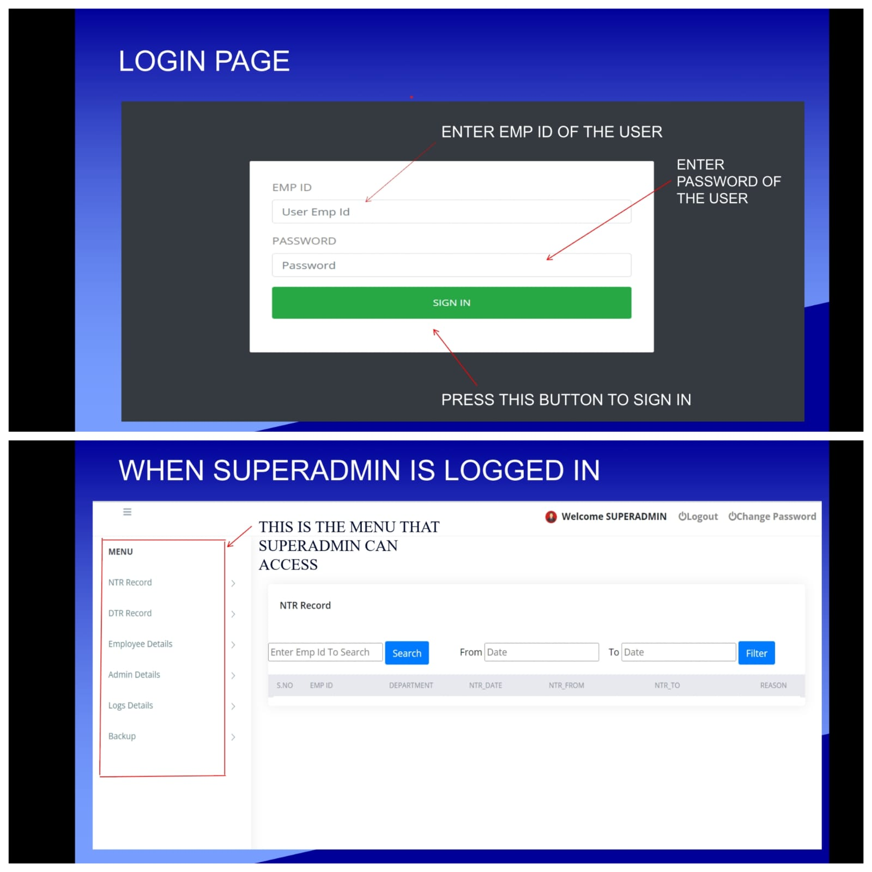

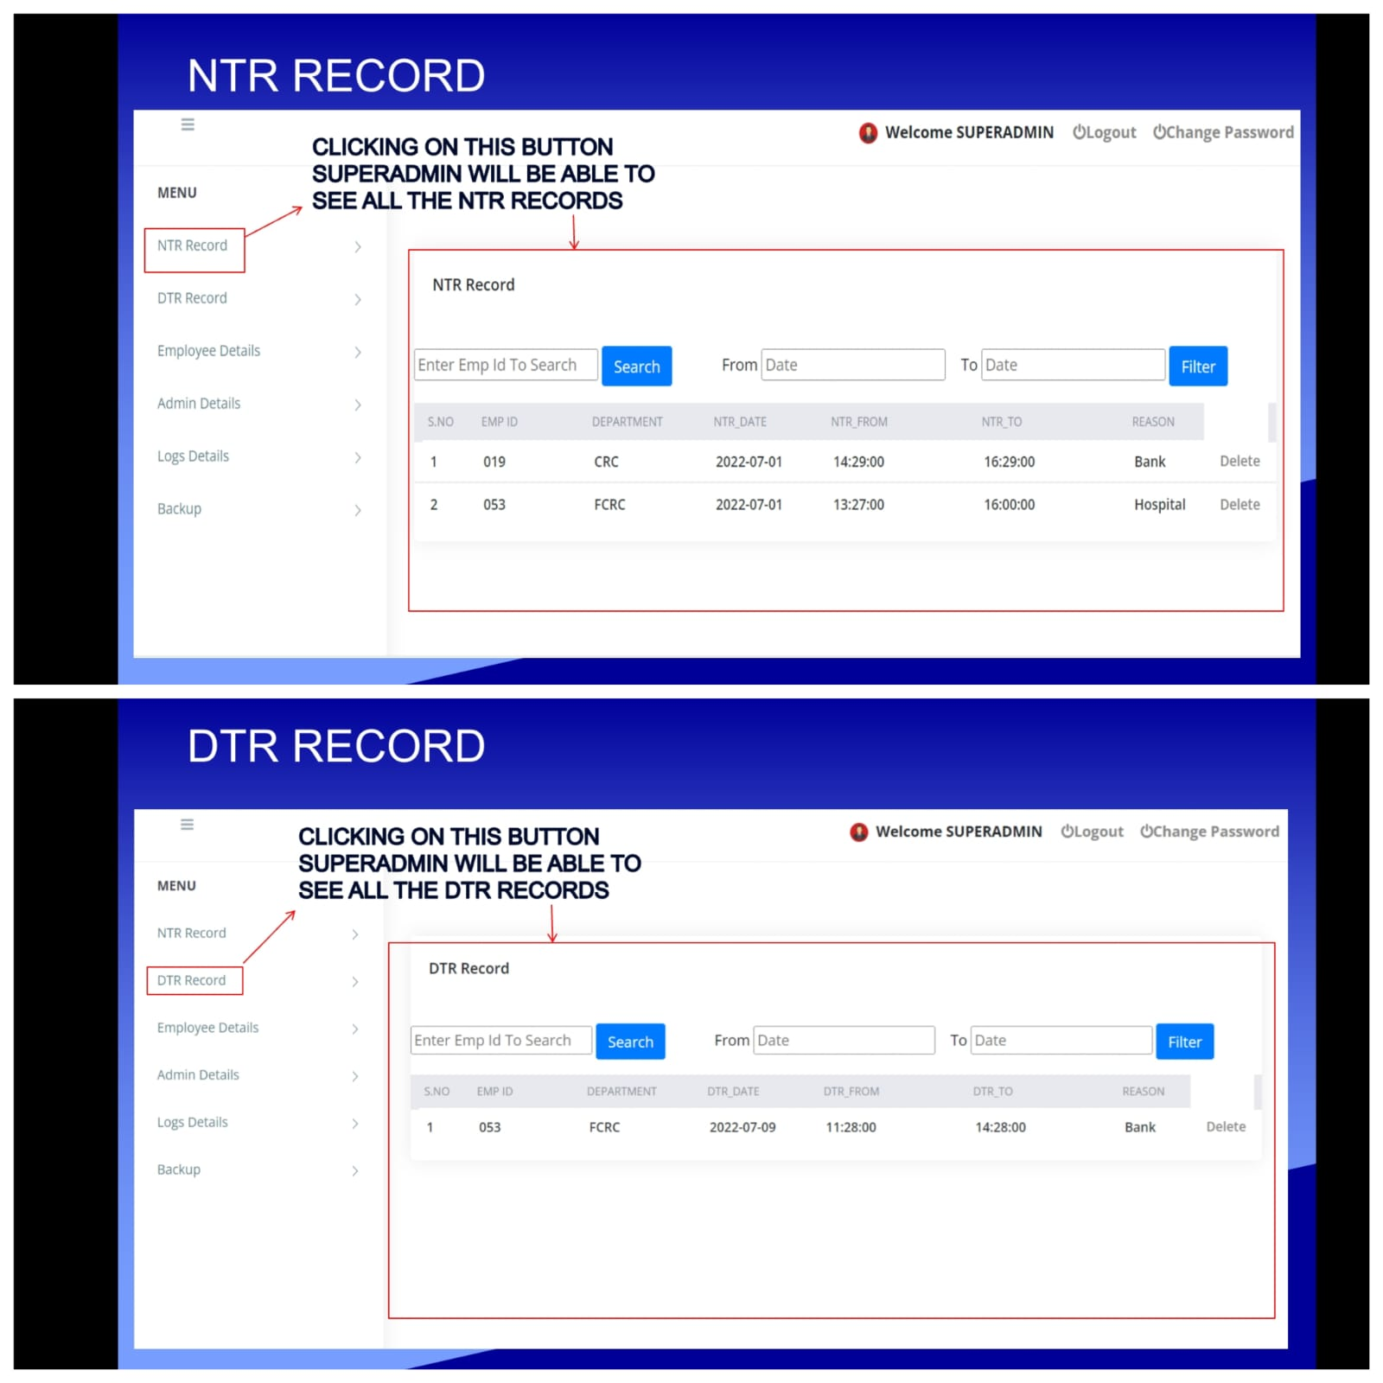

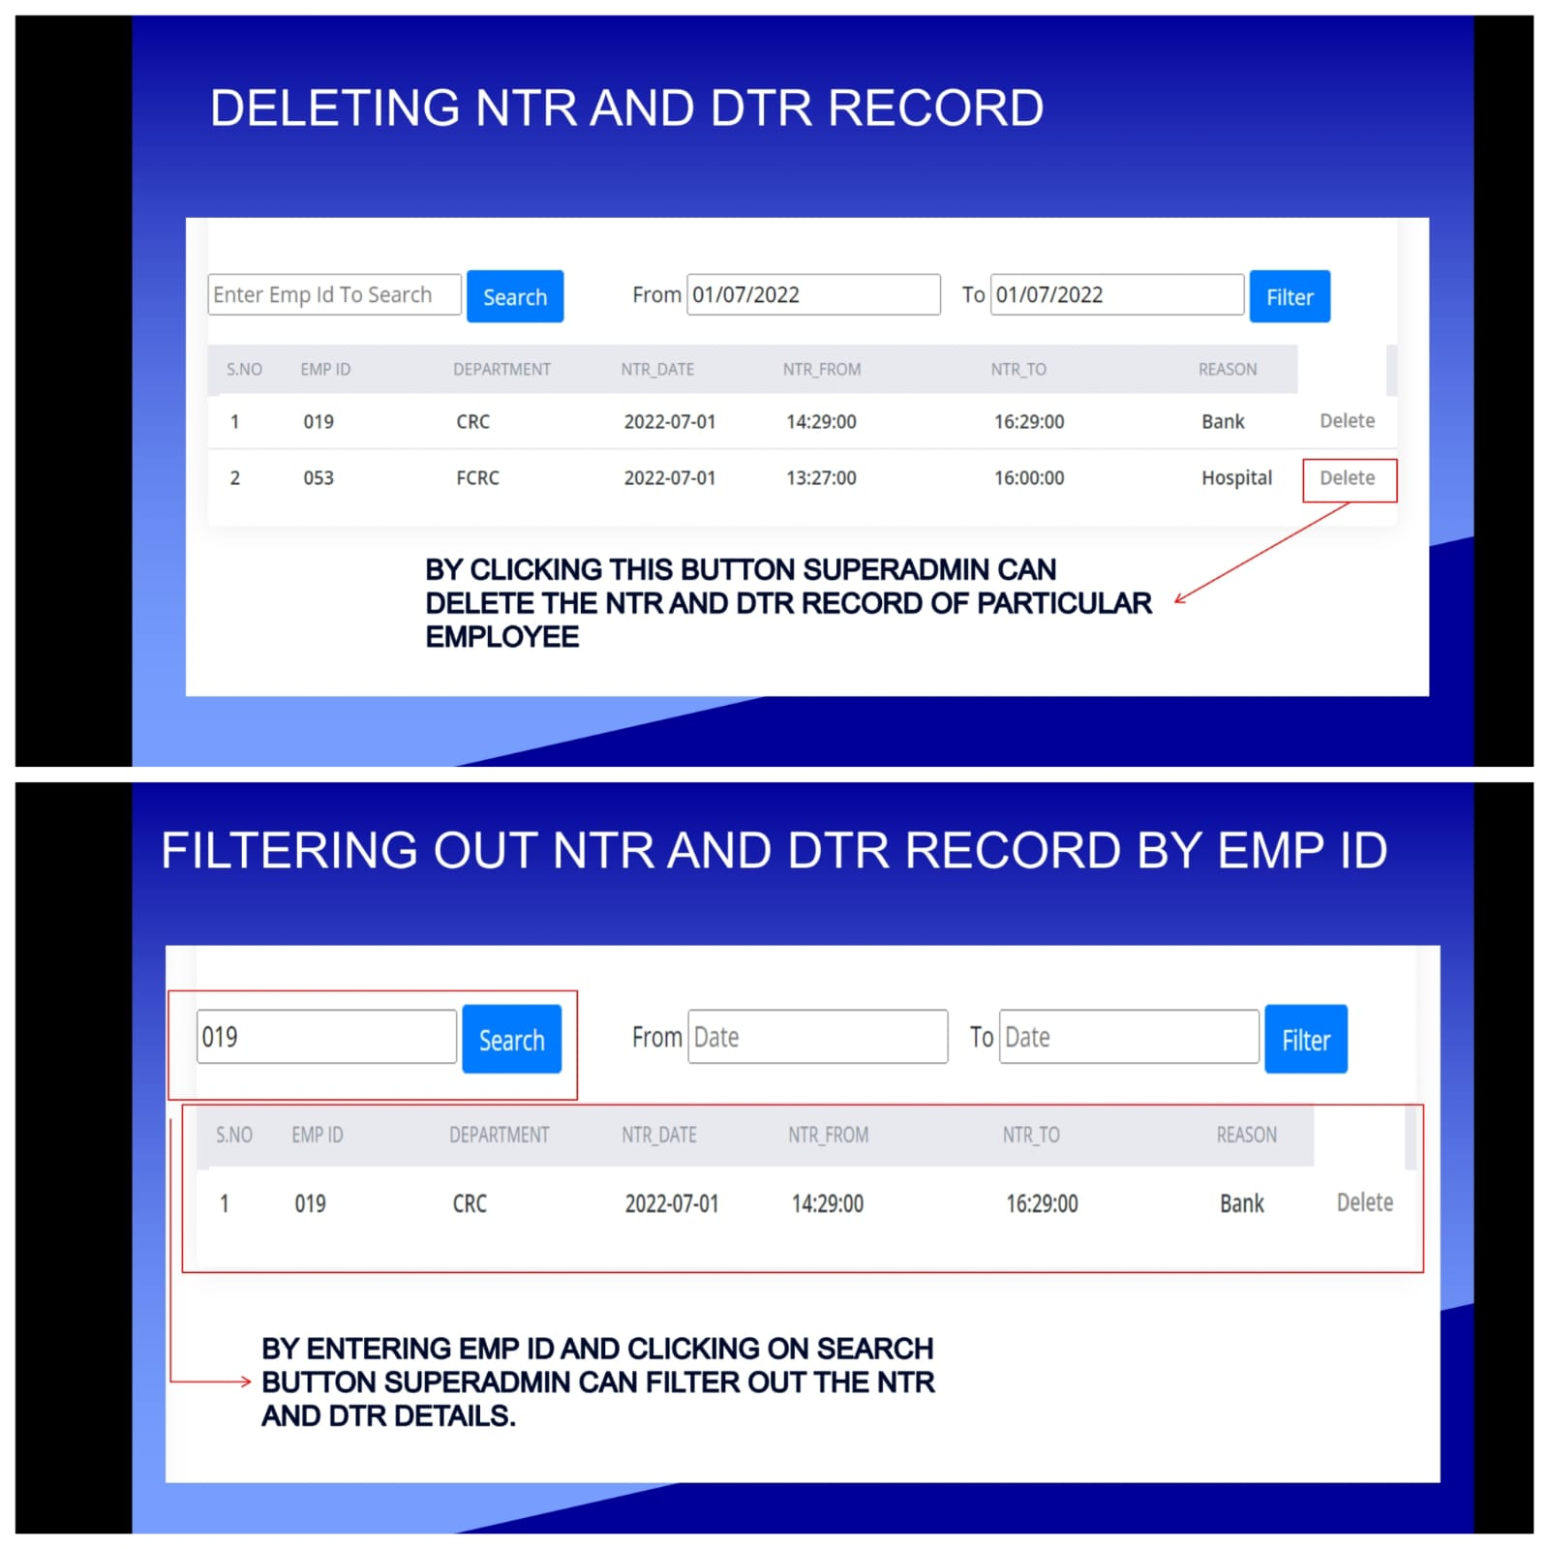

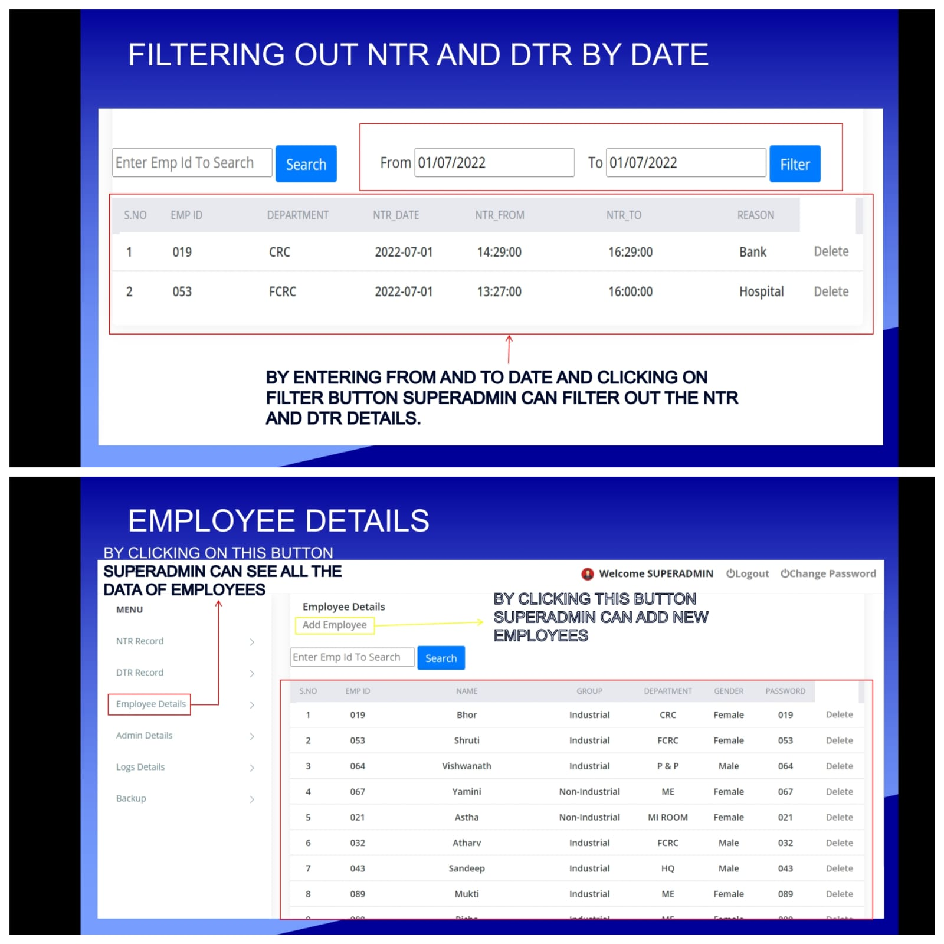

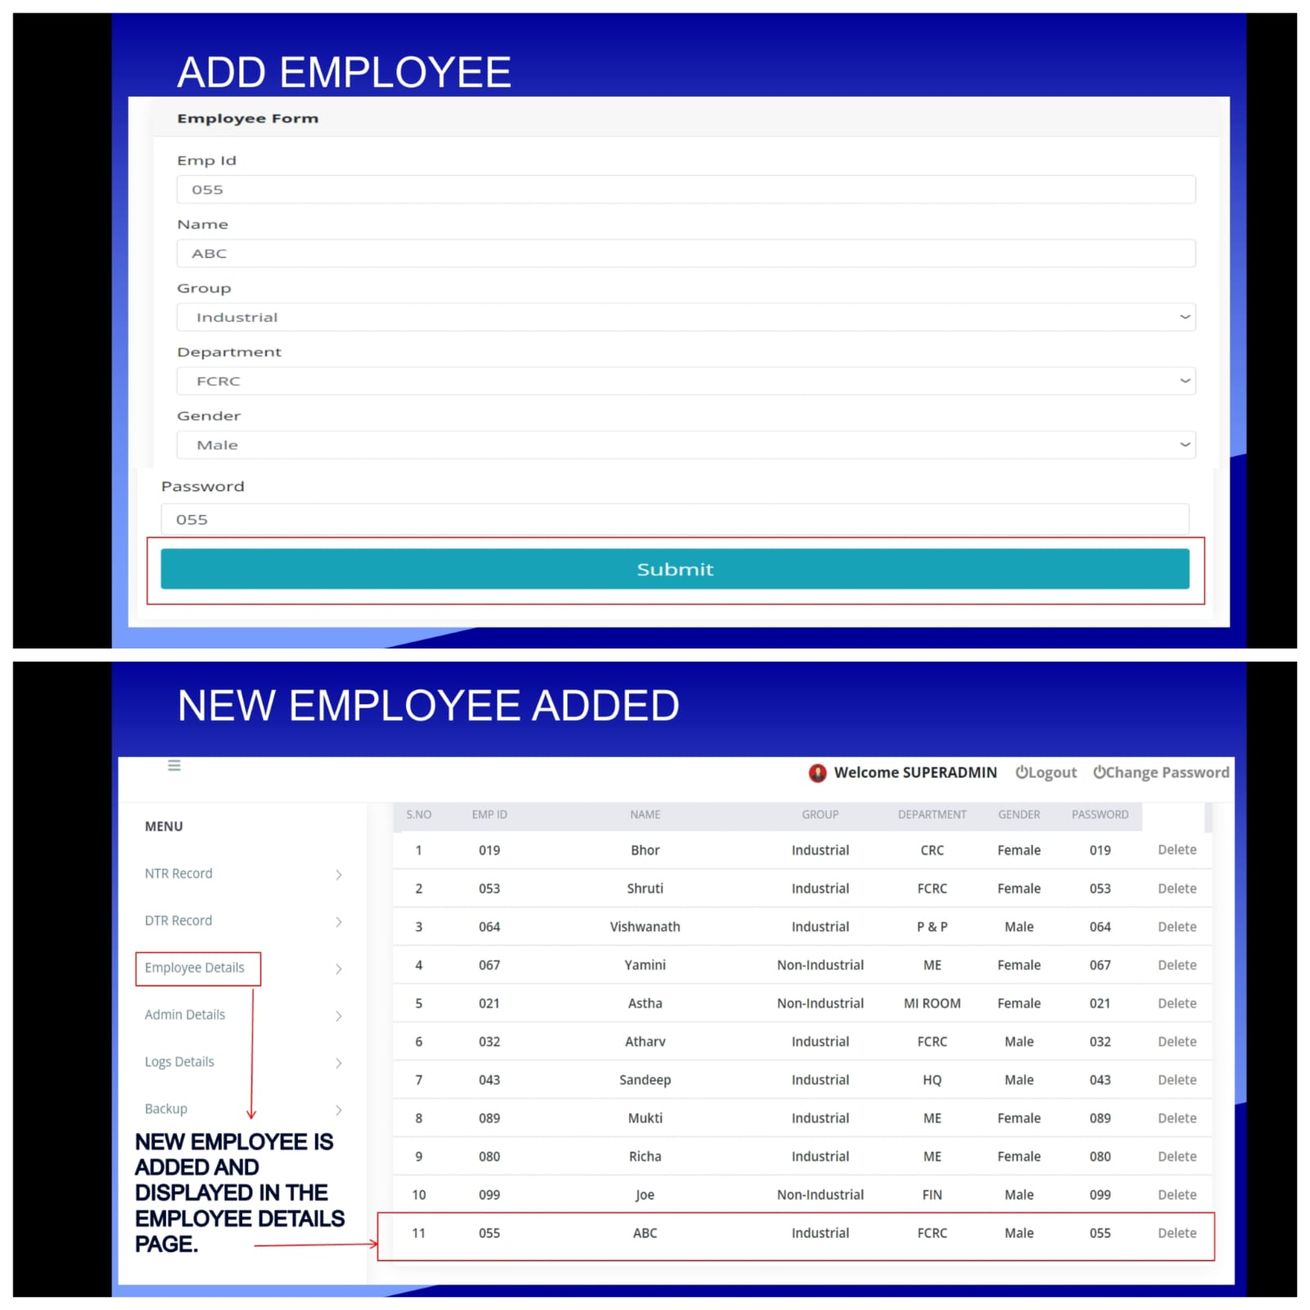

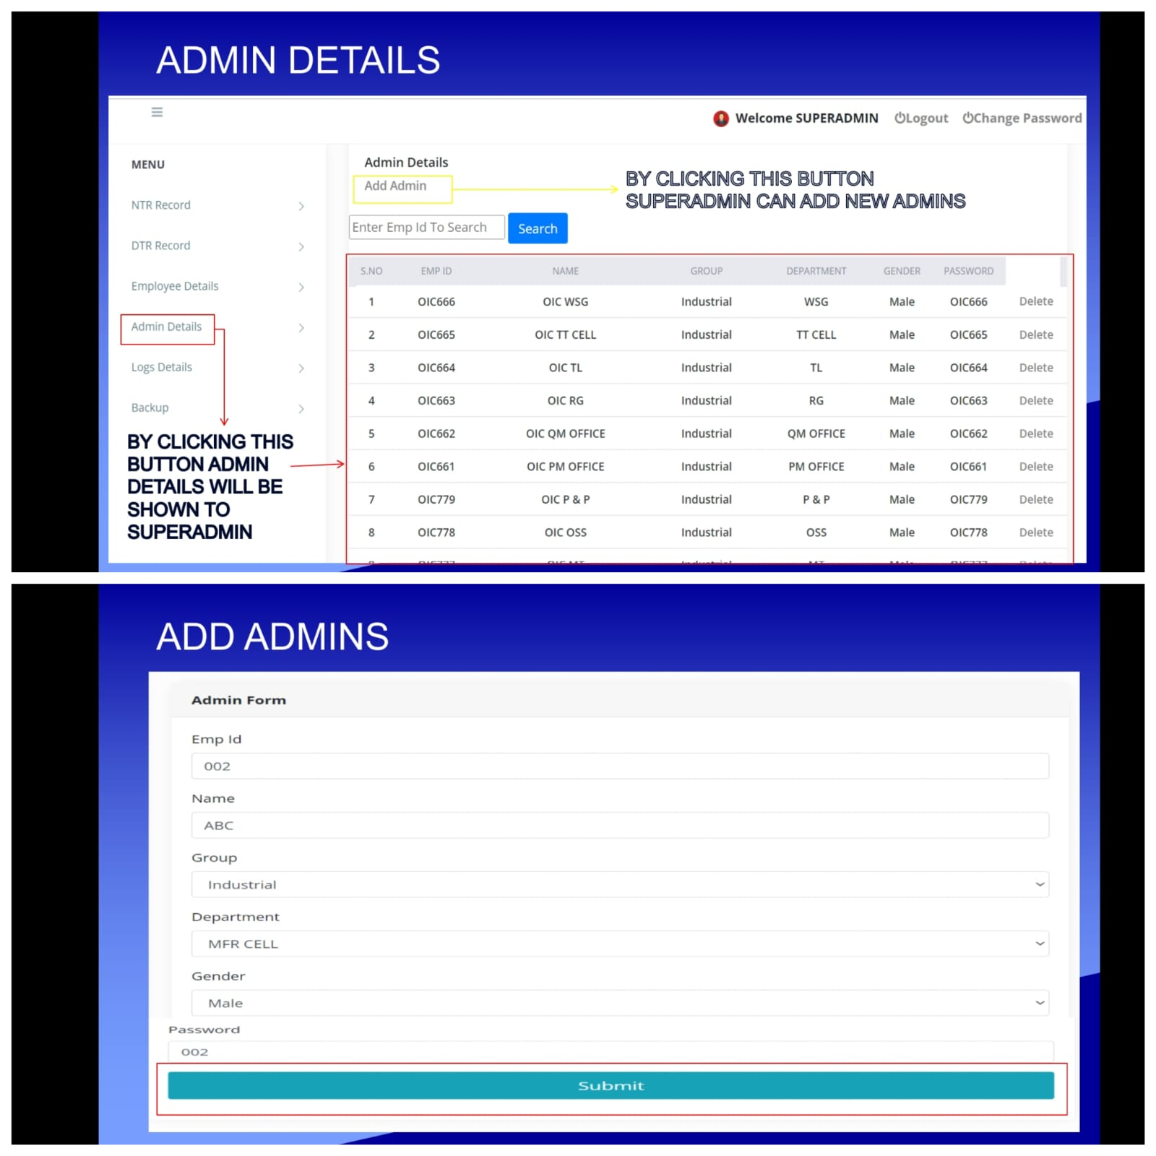

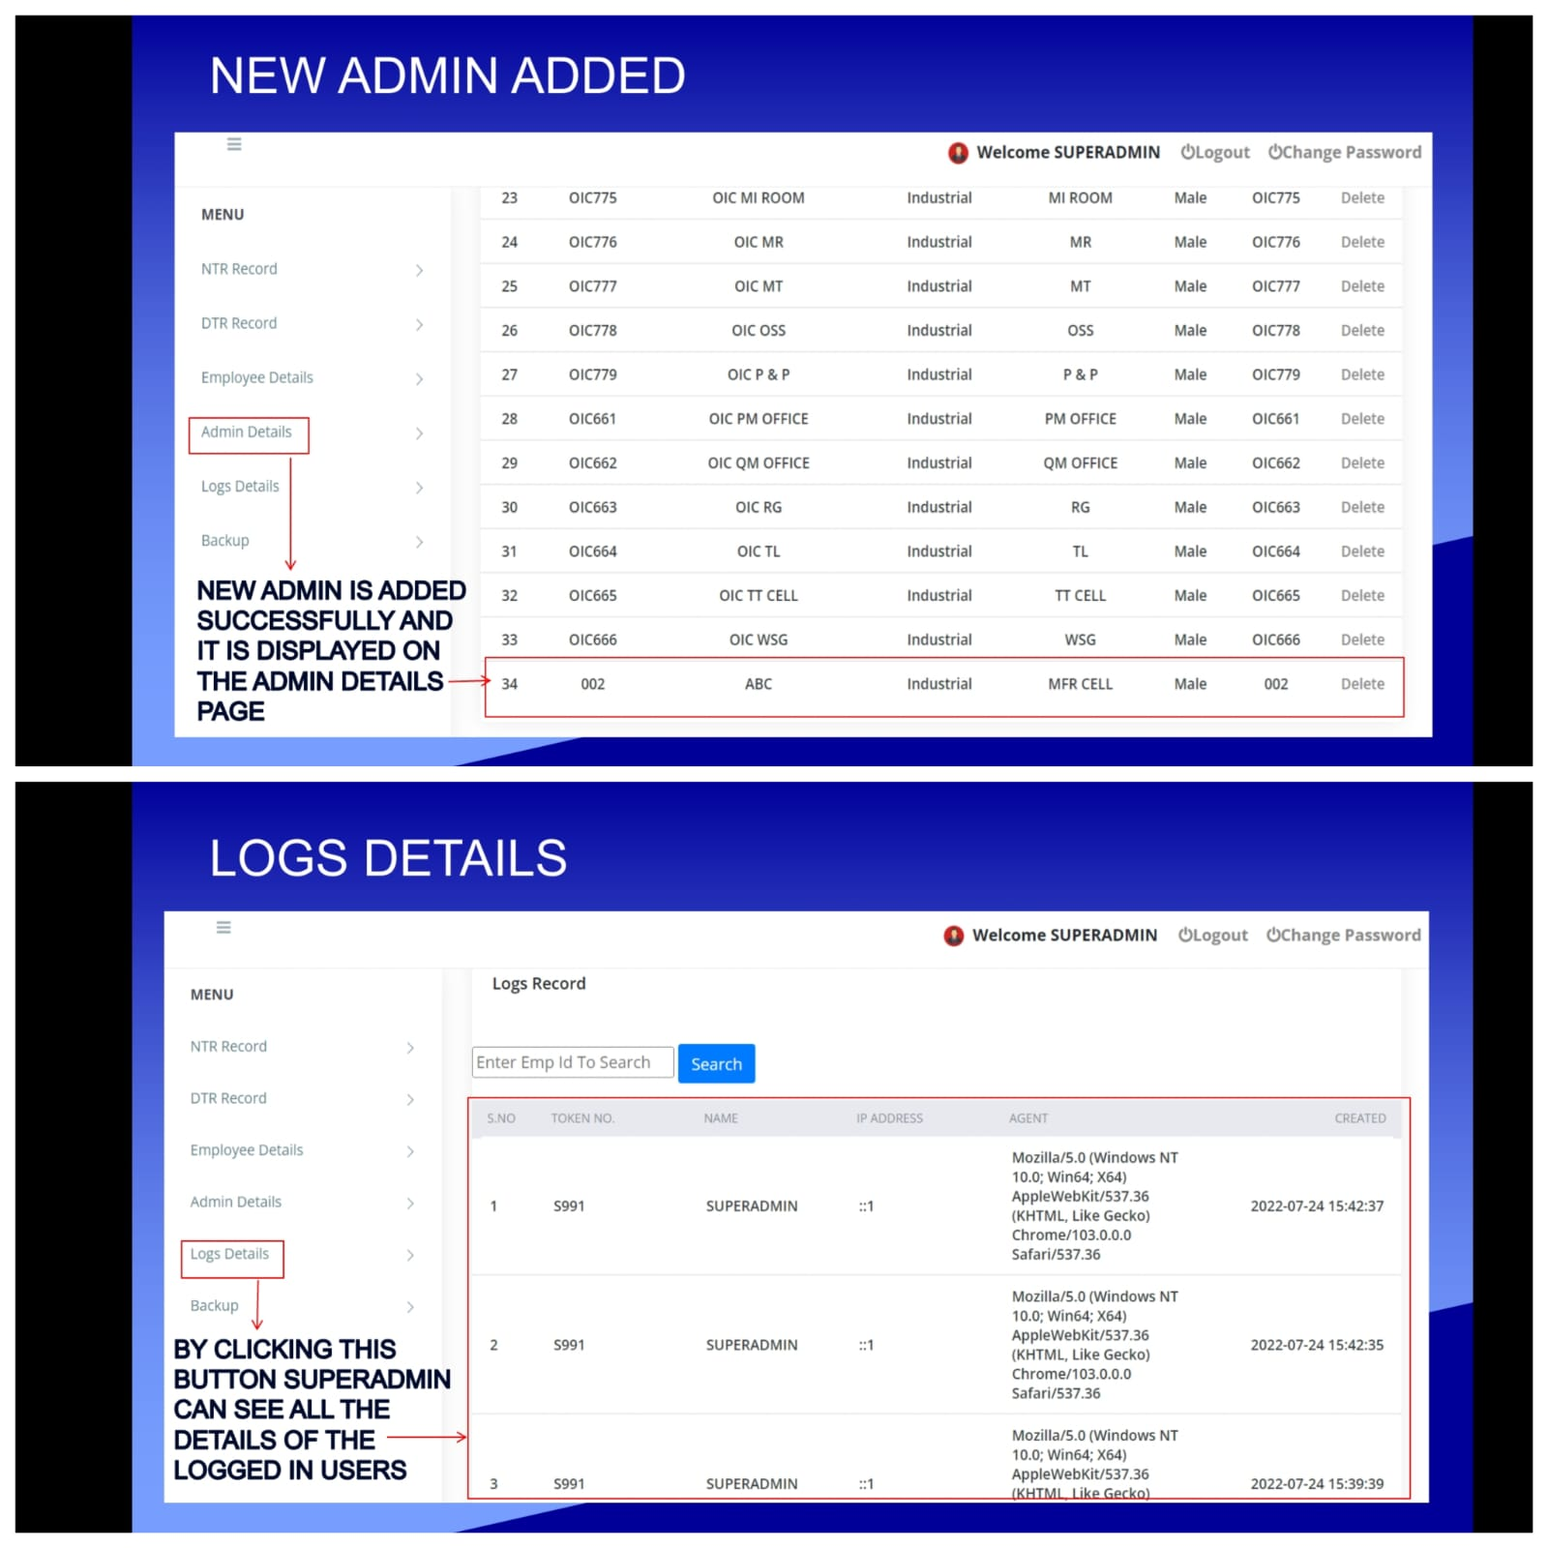

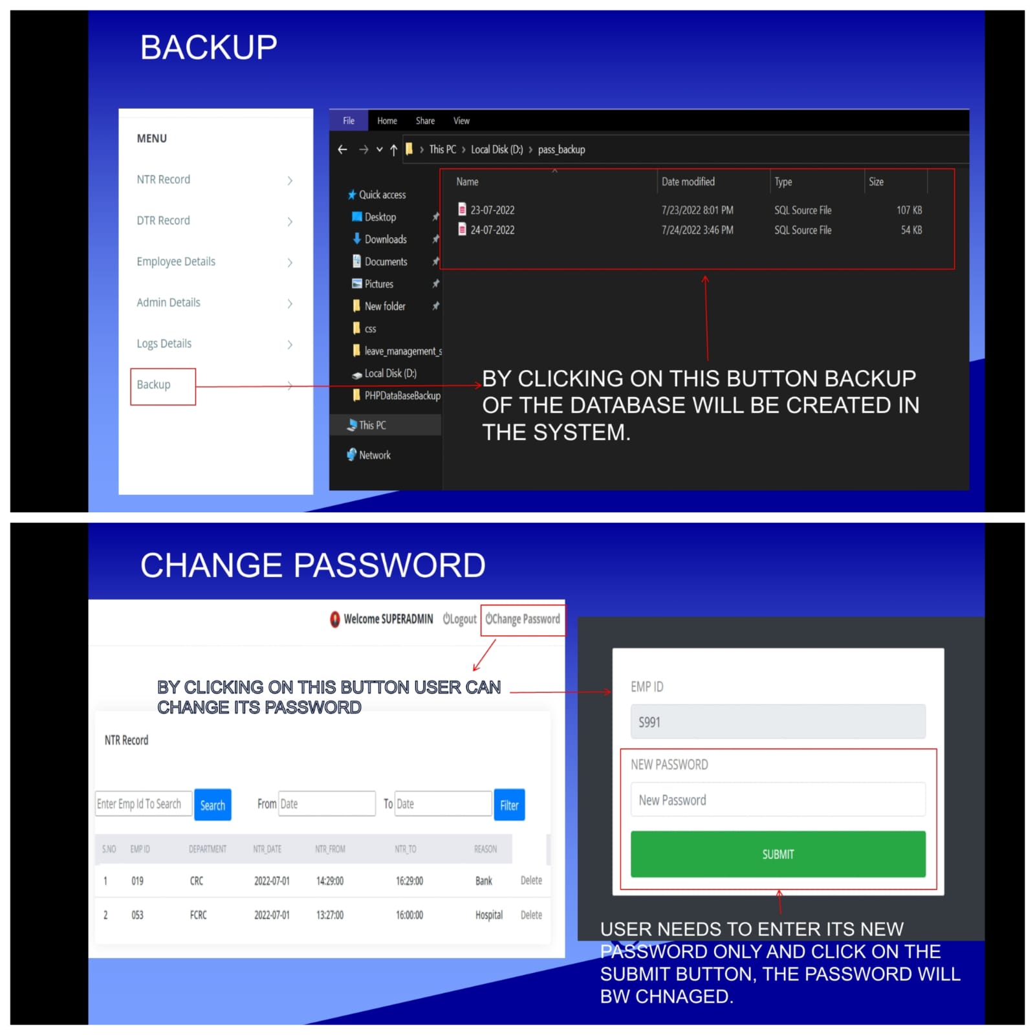

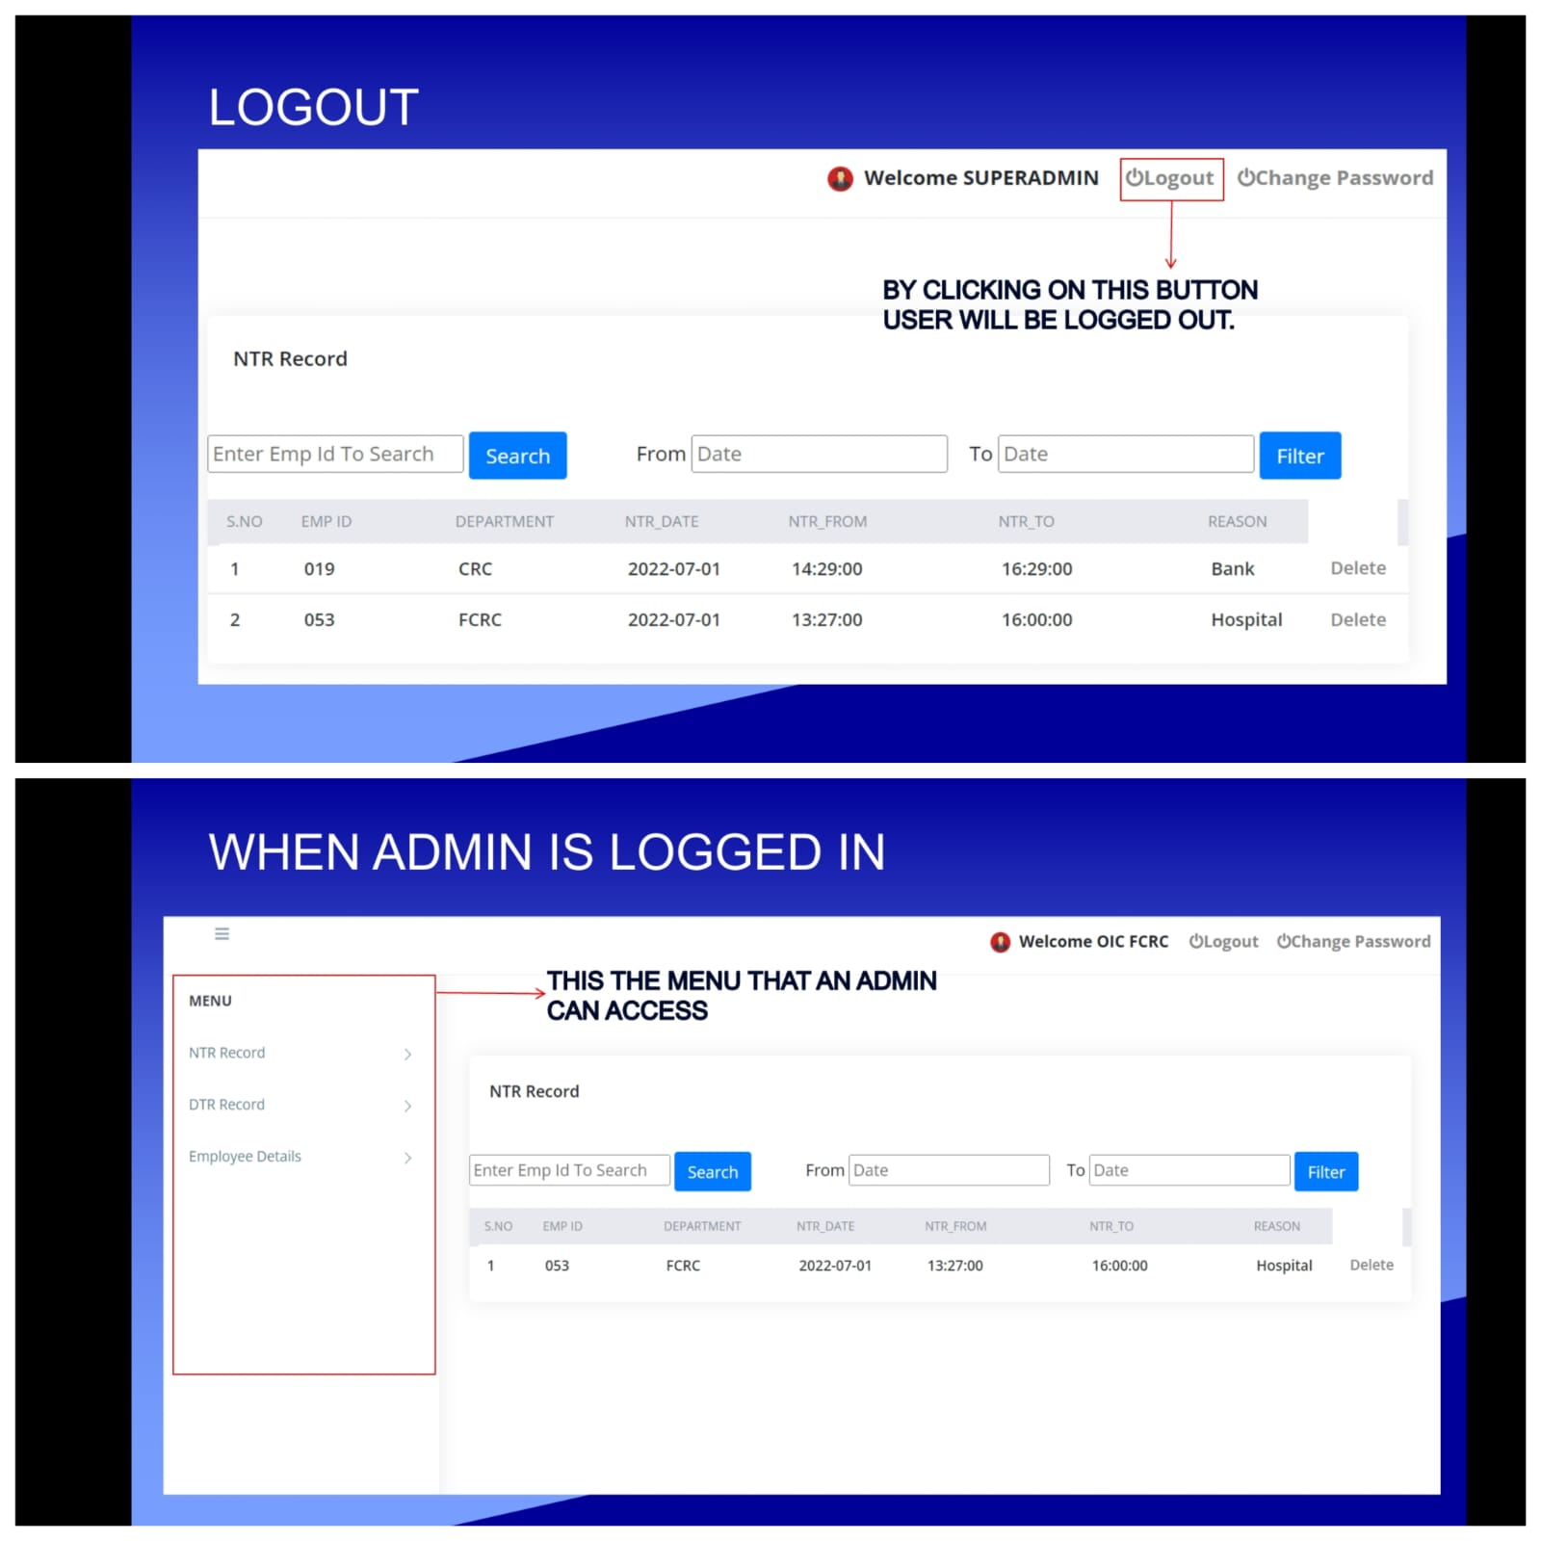

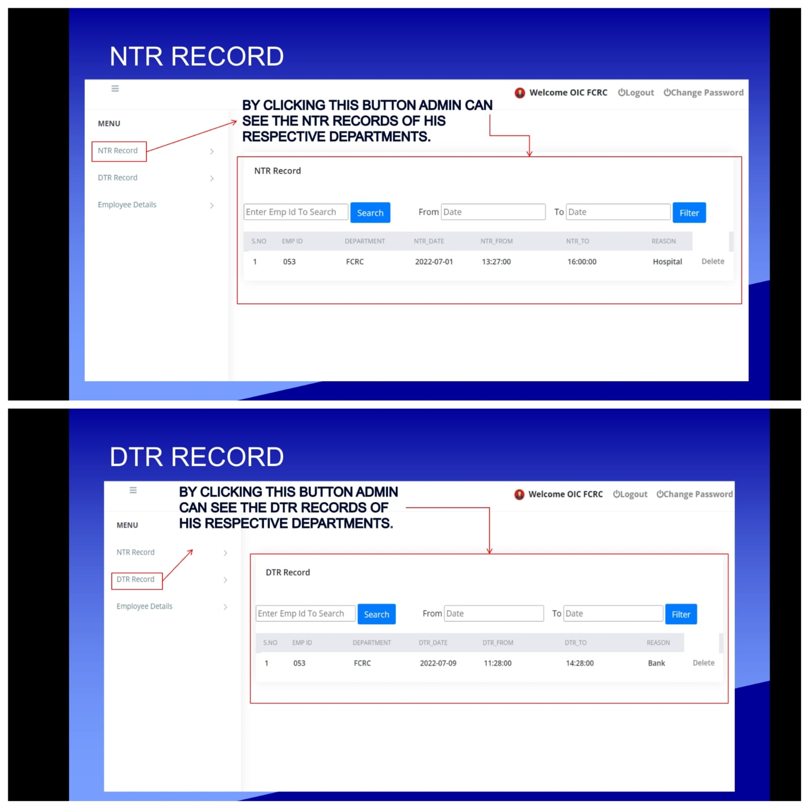

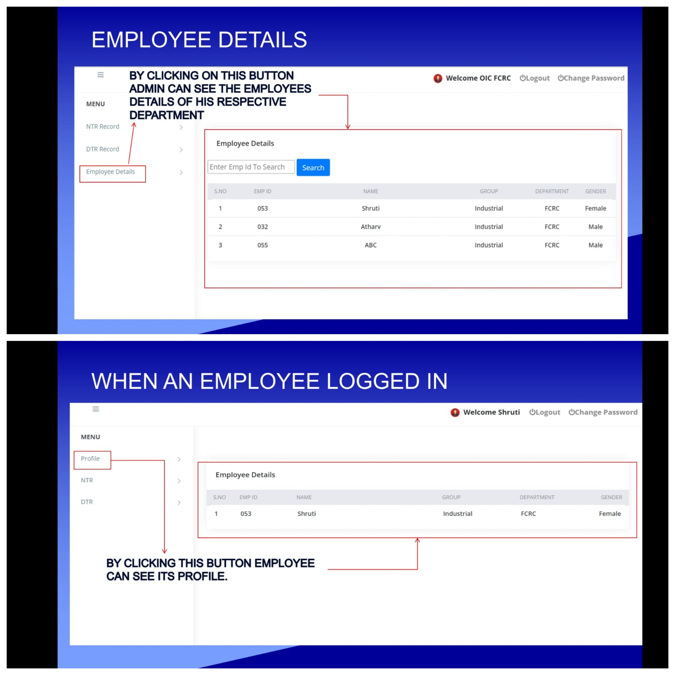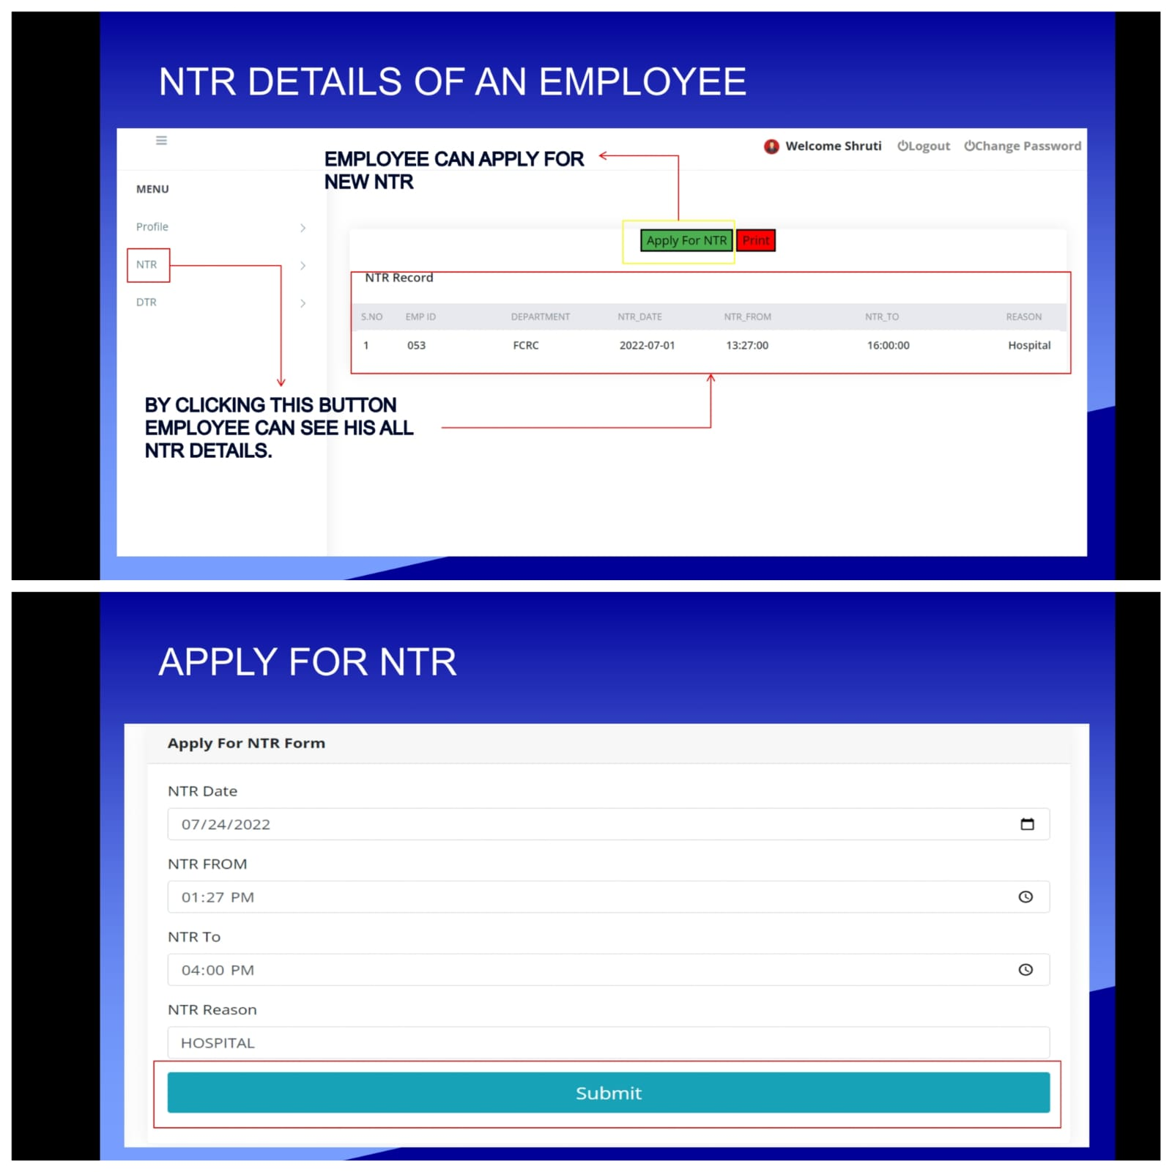

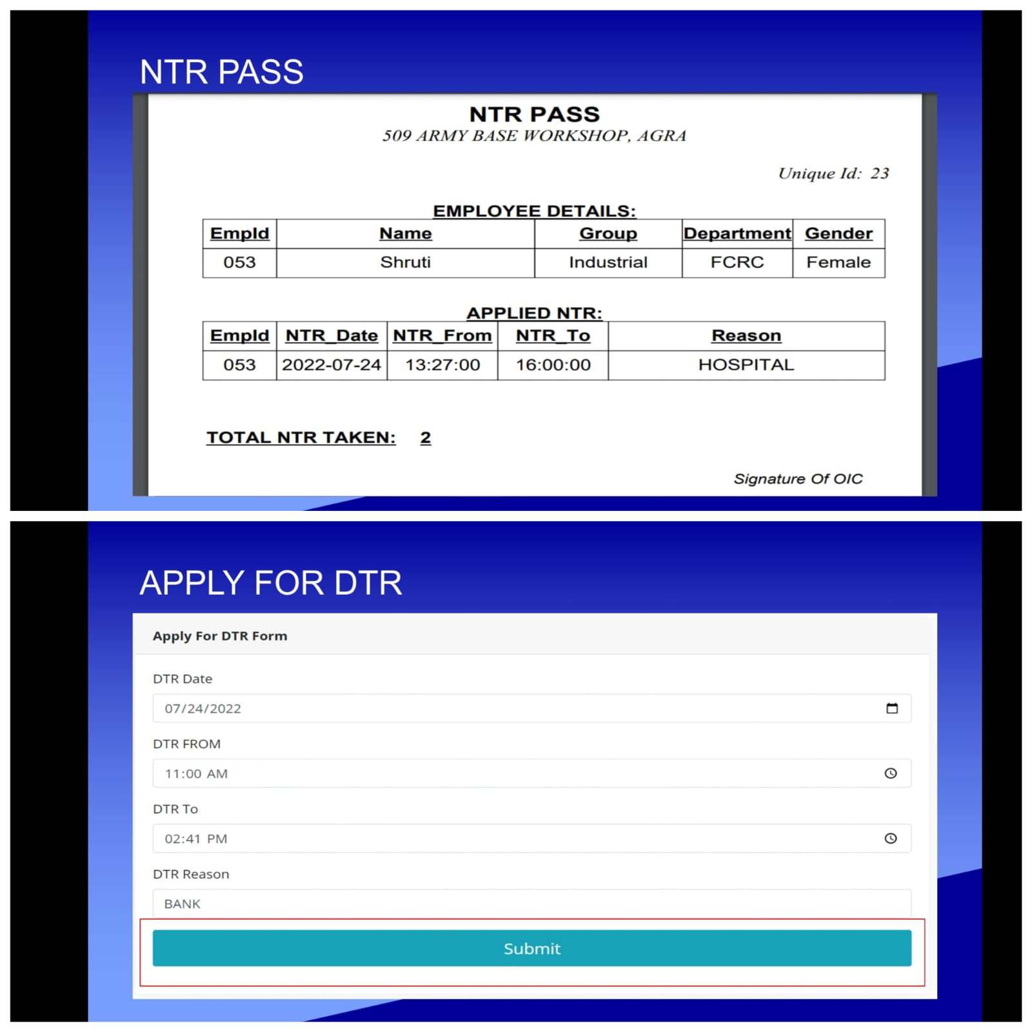

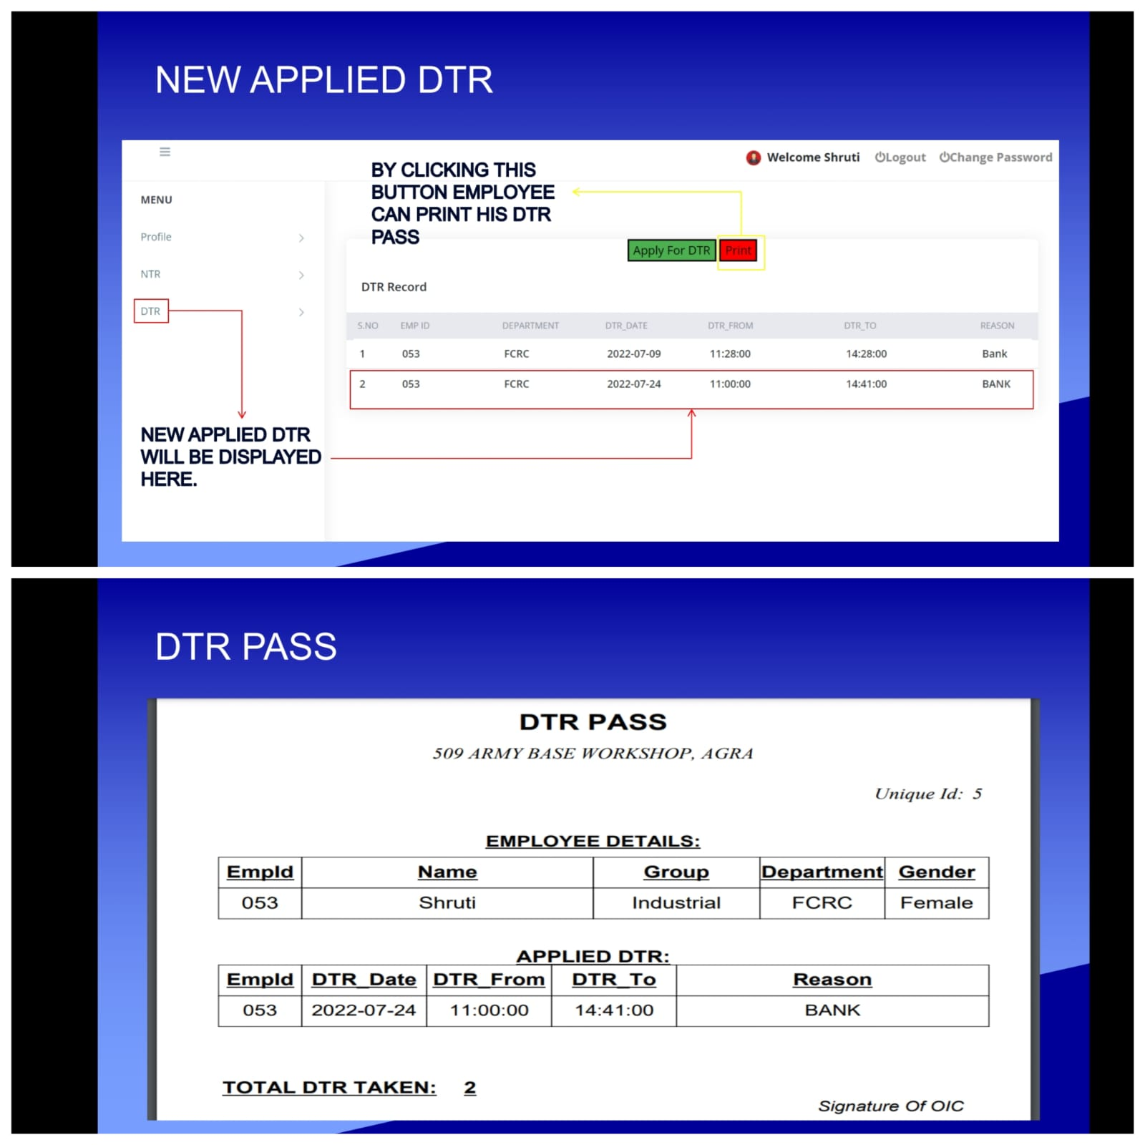

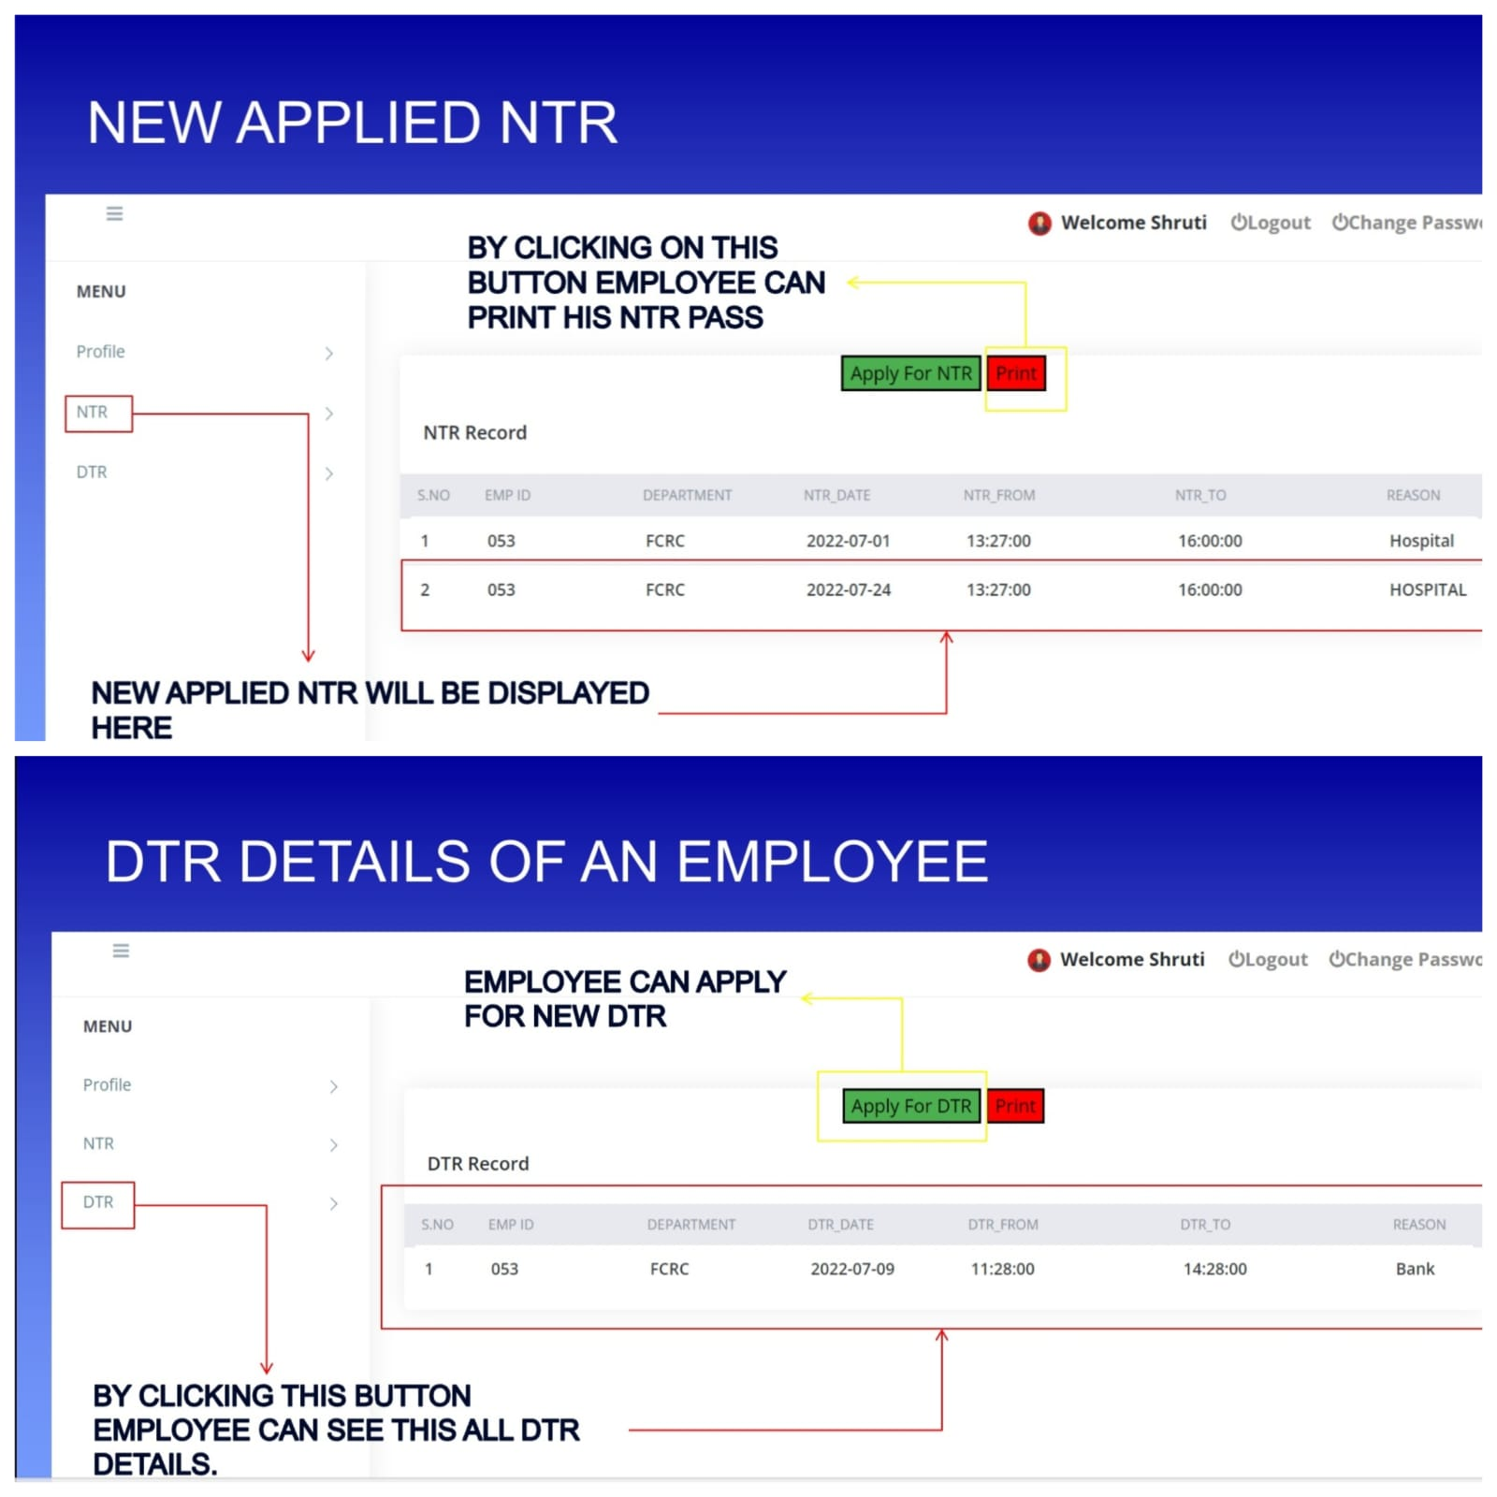

.

## 8. Limitation of Project on Pass Management System

Although we have put our best efforts to make the software flexible, easy to operate but some limitations cannot be ruled out even by us. Though the software presents a broad range of options to its users some intricate options could not be covered into it; partly because of logistic and partly due to lack of sophistication. Paucity of time was also major constraint, thus it was not possible to make the software foolproof and dynamic. Lack of time also compelled us to ignore some parts like facility to update the data by Super Admin.

Considerable efforts have made the software easy to operate even for the people not related to the field of computers but it is acknowledged that a layman may find it a bit problematic at the first instance. The user is provided help at each step for his convenience in working with the software.

## 9.Future Scope of the Project:

In a nutshell, it can be summarized that the future scope of the project circles around maintaining information regarding:

* We can add printer in future.
* We can give more advance software for Pass Management System including more facilities.
* Integrate multiple load balancers to distribute the loads of the system
* Create the master and slave database structure to reduce the overload of the database queries
* Implement the backup mechanism for taking backup of codebase and database on regular basis on different servers

The above mentioned points are the enhancements which can be done to increase the applicability and usage of this project. Here we can maintain the records of Employee and NTR/DTR taken by him. There is a scope for introducing a method to maintain the Pass Management System. Enhancements can be done to maintain all the Employee, NTR/DTR, Previous NTR/DTR details.

We have left all the options open so that if there is any other future requirement in the system by the user for the enhancement of the system then it is possible to implement them.

In the last we would like to thanks all the persons involved in the development of the system directly or indirectly. We hope that the project will serve its purpose for which it is develop there by underlining success of process.

**10.Conclusion**

Our project is only a humble venture to satisfy the needs to manage their project work. Several user-friendly coding have also adopted. This package shall prove to be a powerful package in satisfying all the requirements of the organization. The objective of software planning is to provide a frame work that enables the manger to make reasonable estimates made within a limited time frame at the beginning of the software project and should be updated regularly as the project progresses. This System is completely secure since every user is provided with user ID and Password so there is no chance of any unauthorized access

### **At the end it is concluded that we have made effort on following points…**

* A description of the background and context of the project and its relation to work already done in the area.
* Made statement of the aims and objectives of the project.
* The description of Purpose, Scope, and applicability.
* We define the problem on which we are working in the project.
* We describe the requirement Specifications of the system and the actions that can be done on these things.
* We understand the problem domain and produce a model of the system, which describes operations that can be performed on the system.
* We included features and operations in detail, including screen layouts.
* We designed user interface and security issues related to system.

Finally, the system is implemented and tested according to test cases

### **11.References and Bibliography:**

* + Google for problem solving
  + <http://www.pythonworld.com/pythonworld/jw-01-1998/jw-01->Credentialreview.html
  + Database Programming with JDBC and Python by O'Reilly
  + Head First Python
  + <http://www.jdbc-tutorial.com/>
  + Python and Software Design Concepts by Apress
  + https://[www.tutorialspoint.com/python/](http://www.tutorialspoint.com/python/)
  + <http://www.pythontpoint.com/python-tutorial>
  + https://docs.oracle.com/javase/tutorial/
  + <http://www.wampserver.com/en/>
  + <http://www.Django.net/>
  + <http://www.tutorialspoint.com/mysql/>
  + httpd.apache.org/docs/2.0/misc/tutorials.html